SVM-DR Operational Procedures

Thursday, October 12, 2017

10:01 AM



Standard Operation Procedure

Managing SVM DR Relationships

Prepared for <customer> Version 1.0

**Table of Contents**

**Overview**

**1.** **Preparation for SVM DR relationships**

**2.** **Creating a SVM DR relationship**

**3.** **Manually switchover services to the destination**

**4.** **Switch Back after the new Hardware is in place**

**5.** **Switch Back after maintenance**

**6.** **Fencing off the disaster site**

**Appendix: Reference Information**

* 1. **Overview**

NetApp clustered Data ONTAP can be managed two ways. Either through SSH using the cluster shell CLI or through HTTPS using the integrated OnCommand System Manager WebGUI.

To connect to the cluster shell, open a SSH session to the cluster management IP and provide login credentials.

To open up the integrated OnCommand System Manager, open a supported web browser and enter the cluster management IP in the address bar. <http://cluster_management_IP/>

Your browser will be redirected to the secured URL of the Cluster Management web interface automatically and a prompt for the log in credentials appears.

List of abbreviations

SVM Storage Virtual Machine

DR Disaster Recovery

* 1. **Preparation for SVM DR relationships**

Before you begin, make sure to have the following information available:

* 1. Name of the source Cluster (Management IP address)
  2. Name of the source SVM
  3. Name of the destination Cluster (Management IP address)
  4. Name of the destination SVM
  5. Update frequency and the name of the configured schedule
  6. Make sure the Cluster Peering (Intercluster) has been established

Below procedure is based on the following environment variables:

Source Cluster ohio

Source SVM svm-test

Destination Cluster springfield

Destination SVM svm-test-dr

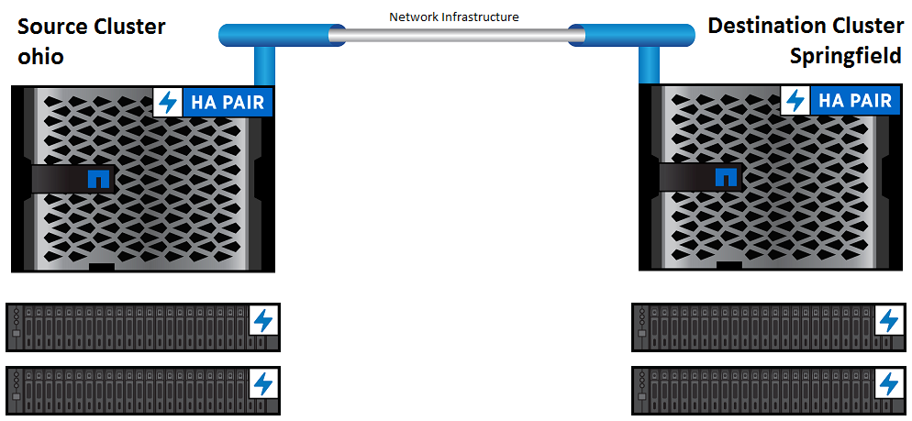

* 1. **Creating a SVM DR relationship**

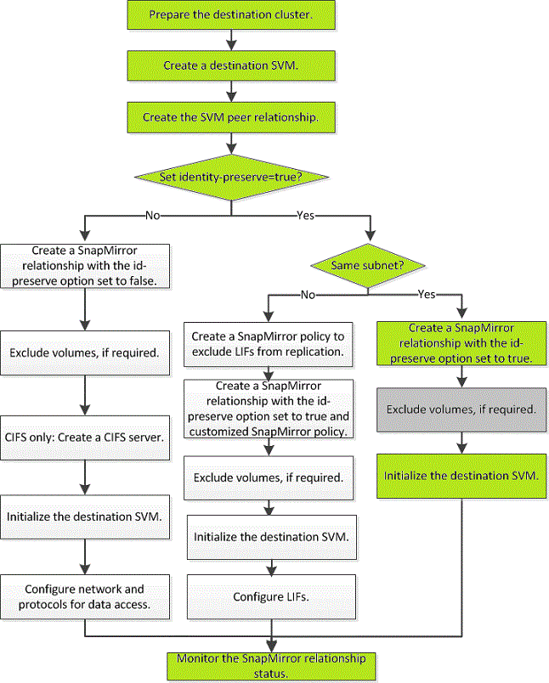

**Below red lines are imp we faced issues in yisnas1**

**-🡪**cluster peer create -peer-addrs 192.168.2.203,192.168.2.204

**Cluster peer health show**

**Cluster peer show -instance**

**yisntap1::> df -V -g -vserver yisnas4**

**yisntap2::>job schedule cron create -name transition_snapshot_schedule_3 -minute 0 -hour 12**

**job schedule cron create -name transition_snapshot_schedule_2 -minute 0 -hour 00**

**yisntap2::>cron show**

**job schedule cron create -name daily8PM -minute 0 -hour 20 -dayofweek Sunday, Monday, Tuesday, Wednesday, Thursday, Friday**

**job schedule cron create -name weekly8PM -minute 0 -hour 20 -dayofweek sat**

**1. Check Intercluster network and cluster peering**

Make sure source and destination clusters have the required number of Intercluster lifs and check the cluster peering has been established.

springfield::> net int show -fields address,netmask,role

(network interface show)

vserver lif role address netmask

------- ------------- ------- ------------- -----------

springfield springfield-01-ic1 Intercluster 192.168.0.1 255.255.255.0

springfield springfield-02-ic2 intercluster 192.168.0.2 255.255.255.0

ohio::> net int show -fields address,netmask,role

(network interface show)

vserver lif role address netmask

------- ------------- ------- ------------- -----------

ohio ohion-01-ic1 Intercluster 192.168.0.3 255.255.255.0

ohio ohion-02-ic2 intercluster 192.168.0.4 255.255.255.0

springfield::> cluster peer show

Peer Cluster Name Cluster Serial Number Availability Authentication

------------------------- --------------------- -------------- --------------

ohio 1-80-000000 Available ok

**2. Create DR SVM**

First step is to create a SVM on the destination cluster, which will assume ownership of the services in case of a disaster. This SVM will preserve the identity of the source SVM after a switch over.

springfield::> vserver create -vserver svm-test-dr -subtype dp-destination

[Job 2089] Job succeeded:

Vserver creation completed

**3. Modify the allowed aggregate list**

Since the aggregate hosting the mirror volumes can’t be specified, it is recommending to modify the allowed aggregate list of the new disaster recovery SVM

springfield::> vserver modify -vserver svm-test-dr -aggr-list aggr1_data

**4. Create Schedule**

For performance reasons, it is recommended to manage the schedule of the snapmirror update schedules. This can be achieved by creating multiple cron schedules on the source and the destination cluster.

springfield::> job schedule cron create -name 15min-05-dr -minute 05,20,35,50

**5. Create Peer Relationship**

Both SVMs need authorization to talk to each other. Hence, a peer relationship needs to be established in addition to the cluster peering.

springfield::> vserver peer create -vserver svm-test-dr -peer-vserver svm-test -applications snapmirror -peer-cluster ohio

Info: [Job 2090] 'vserver peer create' job queued

springfield::> vserver peer show

Peer Peer Peering Remote

Vserver Vserver State Peer Cluster Applications Vserver

----------- ---------- ----------- ----------------- -------------- ---------

svm-test-dr svm-test initiated ohio snapmirror svm-test

1 entries were displayed.

**6. Accept the relationship on the source cluster**

Accept the peering request from the source controller.

ohio::> vserver peer accept -vserver svm-test -peer-vserver svm-test-dr

Info: [Job 23024] 'vserver peer accept' job queued

ohio::> vserver peer show

Peer Peer Peering Remote

Vserver Vserver State Peer Cluster Applications Vserver

----------- ---------- ------------ ----------------- -------------- ---------

svm-test-dr svm-test peered ohio snapmirror svm-test

1 entries were displayed.

**7. Create the snapmirror relationship**

 lovntap2::> snapmirror create -source-vserver lovnas2 -destination-vserver lovnas2_new -type DP -policy DPDefault -schedule 15min-05-dr -identity-preserve true

lovntap2::> snapmirror initialize -destination-path lovnas2_new:

**Create the Snapmirror Policy**

**-discard-configs network**

Initiate a snapmirror relationship to mirror all data to the secondary site.

This will also replicate the SVM identity.

springfield::> snapmirror create -source-vserver svm-test -destination-vserver svm-test-dr -type DP -policy DPDefault -schedule 15min-05-dr -identity-preserve true

springfield::> snapmirror show

Progress

Source Destination Mirror Relationship Total Last

Path Type Path State Status Progress Healthy Updated

----------- ---- ------------ ------- -------------- --------- ------- --------

svm-test: DP svm-test-dr: Uninitialized Idle - true -

**8. Initialize the relationship**

To start the baseline transfer, the relationship needs to be initialized.

springfield::> snapmirror initialize -destination-path svm-test-dr:

springfield::> snapmirror show

Progress

Source Destination Mirror Relationship Total Last

Path Type Path State Status Progress Healthy Updated

----------- ---- ------------ ------- -------------- --------- ------- --------

svm-test: DP svm-test-dr: Uninitialized Transferring - true -

**9. Observe the transfer**

All SVM DR relationships can be monitored by monitoring the snapmirror status of the destination cluster.

springfield::> snapmirror show

Progress

Source Destination Mirror Relationship Total Last

Path Type Path State Status Progress Healthy Updated

----------- ---- ------------ ------- -------------- --------- ------- --------

svm-test: DP svm-test-dr: Snapmirrored Idle - true -

* 1. **Manually switchover services to the destination**

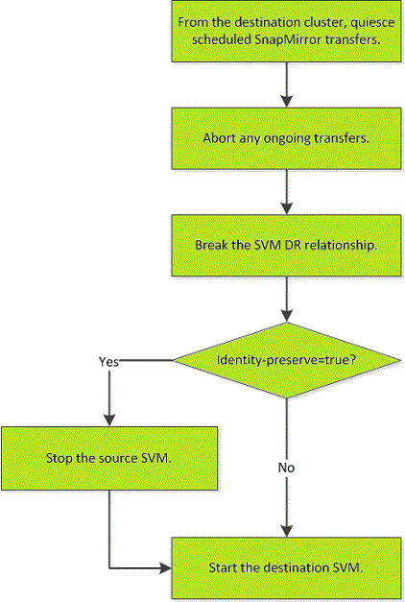

**1. Quiesce the snapmirror schedule**

Quiescing will disable the snapmirror update schedule in order to prevent any updates being started during the switchover.

springfield::> snapmirror quiesce -destination-path svm-test-dr:

springfield::> snapmirror show

Progress

Source Destination Mirror Relationship Total Last

Path Type Path State Status Progress Healthy Updated

----------- ---- ------------ ------- -------------- --------- ------- --------

svm-test: DP svm-test-dr: Snapmirrored Quiesced - true -

**2. Abort any ongoing snapmirror transfer**

If the Total Progress status in the output above is in state “Transferring”, the transfer needs to be aborted. If the status above is “-“, proceed to the next step.

springfield::> snapmirror abort -destination-path svm-test-dr:

**3. Break the relationship**

The relationship needs to be broken-off to make the destination read/writable.

springfield::> snapmirror break -destination-path svm-test-dr:

springfield::> snapmirror show

Progress

Source Destination Mirror Relationship Total Last

Path Type Path State Status Progress Healthy Updated

----------- ---- ------------ ------- -------------- --------- ------- --------

svm-test: DP svm-test-dr: Broken-off Idle - true -

Note: Relationship Status goes back into “Idle” once the relationship has been broken-off. This is by design.

**4. Stop the source SVM**

Stop the services on the source cluster.

ohio::> vserver stop svm-test

[Job 23025] Job succeeded: DONE

**5. Start the DR SVM**

This will start the services via the destination SVM on the secondary site.

springfield::> vserver start svm-test-dr

[Job 2092] Job succeeded: DONE

* 1. **Switch Back after the new Hardware is in place**

Since the new hardware on the main production site comes with a different cluster identifier, different serial numbers and different system IDs, the original relationship can’t be reactivated.

A new relationship is required in order to mirror the data back to the main production site.

However, the procedure to set-up the initial transfer is the same as above.

Once the relationship has been established and the data is fully transferred, the services can be switched over to the main production site using the procedure above.

A little clean-up is required on the destination cluster prior to implementing the new relationship.

**1. Delete the SM relationship**

This will delete the old relationship.

springfield::> snapmirror delete svm-test:

**2. Delete the Peer relationship**

A new peering needs to be done with the new hardware. As preparation, clear the old peering first.

springfield::> vserver peer delete -vserver svm-test-dr -peer-vserver svm-test

**3. Create the new Source SVM and follow the process to create a DR relationship**

The relationship can be initialized by following the procedure in step 2 of this document.

After the baseline sync is completed and the relationship is in idle state, find a maintenance window and manually switch services over to the production site as per procedure in step 3 of this document.

* 1. **Switch Back after maintenance**

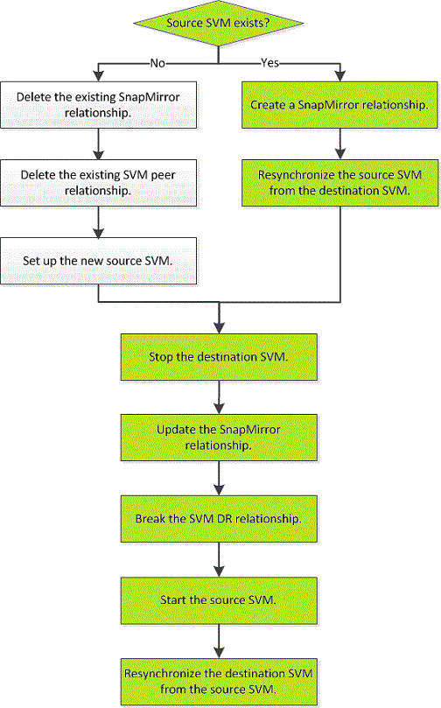

**1. Create a relationship for the resync on the source system.**

The information about the available snapshots are already known by ONTAP. Hence there’s no need for a full baseline data transfer. However, it is necessary to manually create a snapmirror relationship on the source cluster to resync the source from the destination.

ohio::> snapmirror create -source-path svm-test-dr: -destination-path svm-test: -type DP -throttle unlimited -policy DPDefault -schedule 15min-05-dr -identity-preserve true

The relationship will be created in broke-off state as the relationship is already known in the replication database.

ohio::> snapmirror show

Progress

Source Destination Mirror Relationship Total Last

Path Type Path State Status Progress Healthy Updated

----------- ---- ------------ ------- -------------- --------- ------- --------

svm-test-dr: DP svm-test: Broken-off Idle - true -

**2. Resync the relationship**

Once the relationship is available, the data can be synced back to the source cluster.

ohio::> snapmirror resync svm-test:

ohio::> snapmirror show

Progress

Source Destination Mirror Relationship Total Last

Path Type Path State Status Progress Healthy Updated

----------- ---- ------------ ------- -------------- --------- ------- --------

svm-test-dr: DP svm-test: Broken-off Transferring - true -

**3. Stop the destination**

After the data is fully replicated and a maintenance window is available, the services can be switched back to the main production site.

springfield::> vserver stop svm-test-dr

[Job 2093] Job succeeded: DONE

**4. Update the SM relationship**

Perform a final update for replicating the last changes.

ohio::> snapmirror update svm-test:

**5. Break the new update relationship**

Break the relationship to make the source SVM read/writable

ohio::> snapmirror break svm-test:

**6. Start the source SVM**

ohio::> vserver start svm-test

[Job 23026] Job succeeded: DONE

**7. Delete the relationship for cleanup**

The resync relationship is not required anymore and can be deleted to clean-up the system.

ohio::> snapmirror delete svm-test:

**8. To re-establish Data Protection, resync the new source to the destination**

The original relationship needs to be reactivated manually again by using the resync command.

springfield::> snapmirror resync svm-test-dr:

springfield::> snapmirror show

Progress

Source Destination Mirror Relationship Total Last

Path Type Path State Status Progress Healthy Updated

----------- ---- ------------ ------- ------------- --------- ------- --------

svm-test: DP svm-test-dr: Snapmirrored Idle - true -

* 1. **Fencing off the disaster site**

After the disaster, if the disaster site nodes must be replaced, you must halt them to prevent the site from resuming service. Otherwise, you risk the possibility of data corruption if clients start accessing the nodes before the replacement procedure is completed.

Halt the nodes at the disaster site and keep them powered down or at the LOADER prompt until directed to boot DATA ONTAP:

ohio::> system node halt -node ohio-0*

If the disaster site nodes have been destroyed or cannot be halted, turn off power to the nodes and do not boot the replacement nodes until directed to in the recovery procedure.

 A**ppendix: Reference Information**

SVM Disaster Recovery Express Guide <https://library.netapp.com/ecm/ecm_download_file/ECMLP2496252>

SVM Disaster Recovery Preparation Express Guide <https://library.netapp.com/ecm/ecm_download_file/ECMLP2496254>

NetApp Support Website <http://mysupport.netapp.com/>

Utility Tool chest <http://mysupport.netapp.com/tools/index.html>

NetApp Learning Center <http://learningcenter.netapp.com/>

Manual Page Reference <https://library.netapp.com/ecmdocs/ECMLP2348025/html/man_index.html>